MEPS MH Trends and Racial Disparity Paper Outline

1. Introduction
   1. Reported physical and mental health
      1. What scales have people used?
      2. What factors are associated with worse reported physical and mental health?
      3. How has this changed over time?
   2. Economics and health
      1. What does the literature say about how economic factors influence health?
         1. Employment
         2. Income
         3. Insurance
   3. Racial Disparities and Health
      1. What does the literature say about racial disparities and economic factors with respect to poor health outcomes?
      2. What about middle-aged Non-Hispanic (NH) Whites
   4. Who else is doing work like this?
      1. Case and Deaton study- this is the paper we are framing our analysis on.
         1. Case and Deaton show rising mortality among 45-54 year old whites with a high school degree or less from 1999 to 2013, mainly due to more poisonings, suicides and chronic liver disease. These trends reflect declining physical and mental health of subgroups of the population hardest hit by declining economic opportunities.
      2. Anyone else doing work like this in the past 5 years?
   5. Objectives and Hypotheses
      1. To examine trends in reported physical and mental health using a large national data set to understand associated social factors.
      2. There will be racial and gender differences over time in reported physical and mental health scores
      3. While reported mental health scores with remain high and consistent over time for Hispanic and Black middle-aged males, reported mental health scores for White middle aged
2. Methods
   1. MEPS data description -- the Medical Expenditure Panel Survey (1997-2014).
   2. Population description – 45-64 year olds across three racial groups: NH Whites, NH Blacks, and Hispanics. The main analysis is further restricted respondents between the ages of 45 and 54 in two periods: 1996-2000 (n=3,007) and 2011-2014 (n=2,842).
   3. Dependent variable description – The main outcomes are based on reports of mental and physical health. MEPS is a household survey and a single member reports for all household members. They were asked to rate mental and physical separately as excellent, very good, good, fair or poor. For our analysis, we created dichotomous measures indicating a report of fair or poor for each health measure.
   4. Independent variable- Race category
   5. Covariate descriptions – employment, education, gender, insurance, income, and region index
   6. Statistical Analyses
      1. Descriptive statistics-Unadjusted estimates of poorer mental and physical health were calculated for each year between 1996 and 2014 for non-Hispanic whites with less than a college degree for three age groups: 35-44, 45-54 and 55-64.
      2. Regression analyses- multivariable and including interaction terms
         1. In our main analysis, restricting to the earlier and later period, we used logistic regression analyses to understand the association between our covariates and outcomes. An Blinder-Oaxaca decomposition was used to assess the relative importance of changes in covariates. We report results that pooled observations across the two periods. Since we found little differences in these estimates we report the results that pool the data. Sample weights were used to obtain national estimates.
      3. Software
3. Results
   1. Table 1 – descriptive statistics

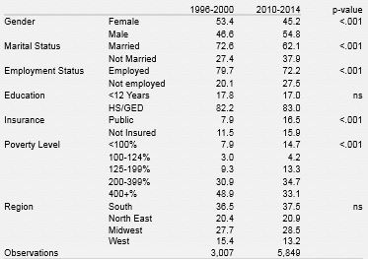

* 1. Table 2- regression estimates

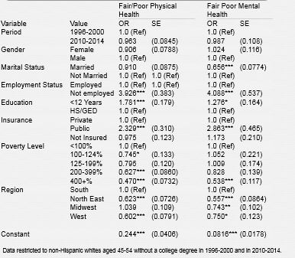

* 1. Table 3- sub-analysis on type of USC
  2. Figure 1- time trend



1. Discussion
   1. Summary of results-
      1. Unadjusted rates for African Americans and Hispanics were relatively stable during the study period (**Results not shown**). Consistent with the findings in mortality rates, we found an increase in the proportion reporting fair or poor physical health for non-Hispanic whites with less than a college degree between the ages of 45 and 54 **(Figure 1).** For this age group, from the late 1990s to the early 2010s, the percentage with reported fair/poor physical health increased from 17.5% to 21.8% (p<.001); those with fair/poor mental health increase from 7.5% to 10.8% (p<.001). An interesting finding is the substantial deterioration in mental health for those between the ages of 55 and 64.
      2. From the earlier (1996-2000) to the later period (2010-2014), the economic circumstances of persons in our 45-54 years old cohort deteriorated substantially, with large increases in poverty, non-employment and no insurance **(Table 1)**. The greater proportion of women reflects in part rising levels of schooling for women during the study period.
      3. Our regression results show that after controlling for observable differences the period effect is non-significant **(Table 2).** For our study group, both reported worse physical and mental health are strongly associated with employment, income and insurance status.
      4. A Blinder-Oaxaca decomposition (**not shown)** indicates that the observed increases in reported fair/poor physical health as well as mental health is almost entirely attributable to changes in levels of employment, insurance coverage and poverty.
   2. Limitations
   3. Implications- Future work is need to understand difference in these patterns across race and ethnicity as well as across age groups.
   4. Conclusions- These findings corroborate the work done by Case & Deaton (2015), demonstrating an overall decline in mental health status among white, middle-aged Americans. The worsening economic circumstances over time account for most of this decline.
2. References- format TBD

Case, A. and A. Deaton (2015). "Rising morbidity and mortality in midlife among white non-Hispanic Americans in the 21st century." Proceedings of the National Academy of Sciences of the United States of America **112**(49): 15078-15083.